TASK 7. SPEAKING (Exam)
Speak on the following topics:
- Computer software
- The future of software technology
- Graphics software
- New software in word-processing.
- New software for children
- Data managed software
- Educational software
- Language software
- Multimedia software
- Simulation software
- Computer networks
- Communication protocols
- Organizational scope (Intranets, Extranet, Internetwork, Internet, Darknet)
- Network configurations
- Network security
- Antivirus software
- Viruses and the Internet
- Computer security
- Current jobs in Tech. Dwell on one you would like to pursue in the future (or already have experience with): 1. UX Writer 2. DevOps engineer 3. Blockchain developer 4. Web developer 5. Data Scientist
- Have you ever tried either virtual reality (VR), augmented reality (AR) or AI in real life? What has that experience been like?
- Name 5 programming languages you know or have heard of. What can you use them for? Tell about one in detail
- What is the difference between Git and Github? Have you ever maintained or contributed to an open source project? What was that experience like?
- Do you use these software products at work or studies? What sort of tasks are they suited for? Do you know any other famous open source projects?
24. How do you manage your schedule? Do you have any tips for keeping a well-organized calendar? Do you use any software development frameworks, such as Scrum, Agile or Kanban?
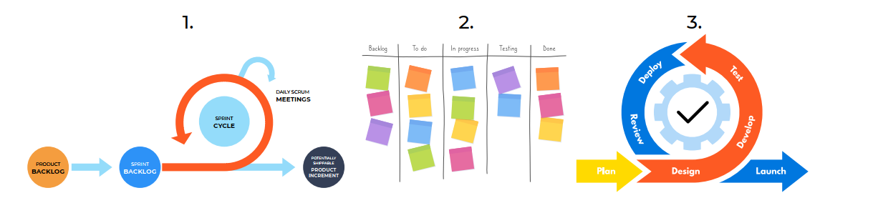
25. Name 3 famous people in tech. What are they famous for? You may tell about one of those listed below (Elon Musk, Linus Torvalds or Satoshi Nakomoto)
